Machine 1



Now change reflect on Machine 2

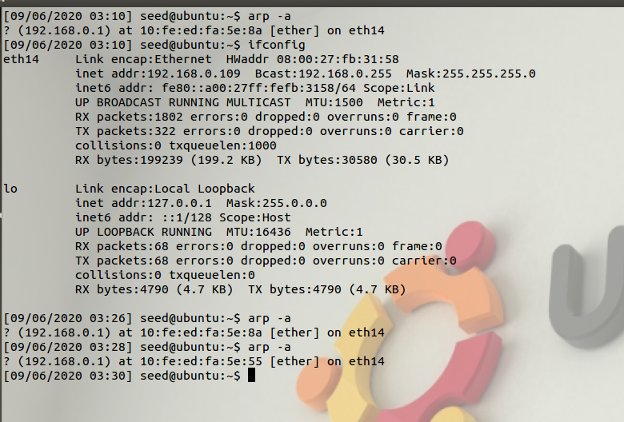

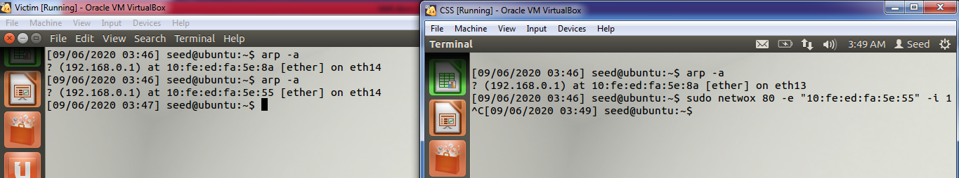

Task No.2

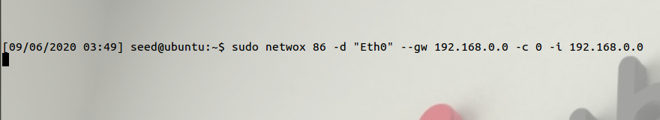

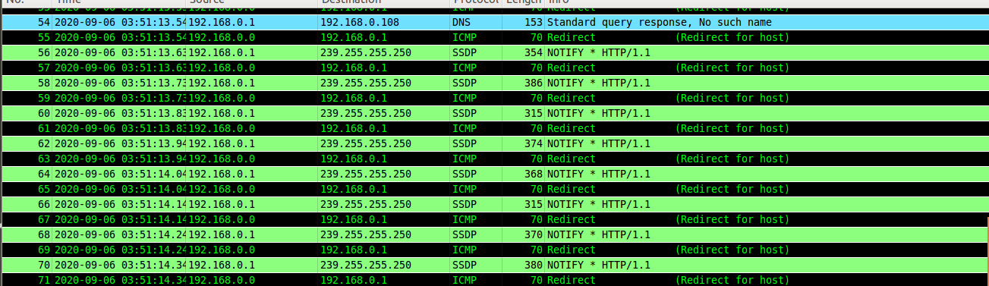

Task No.3

Attacker Machine:

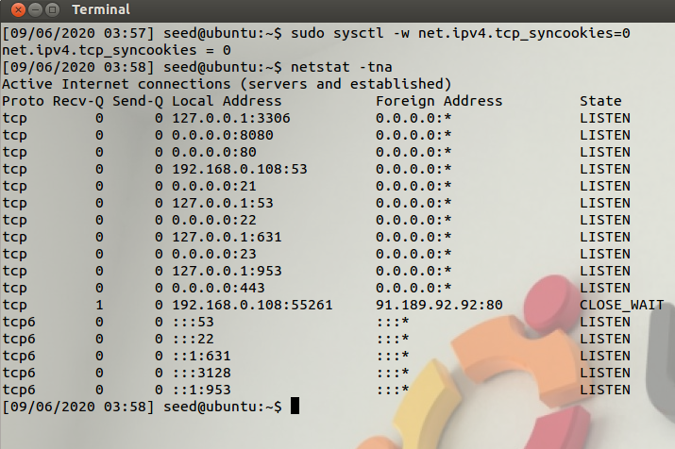

Then run command of netwox

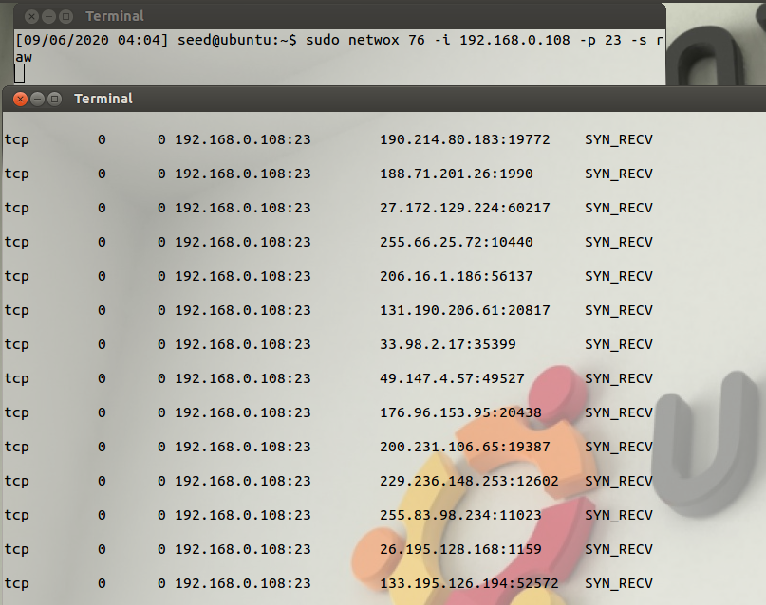

On Client Machine trying to connect but it cant connect because of sysn msg

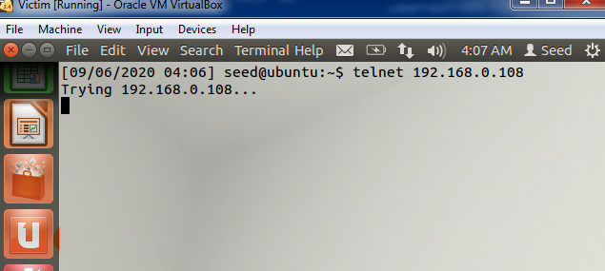

Task no.4

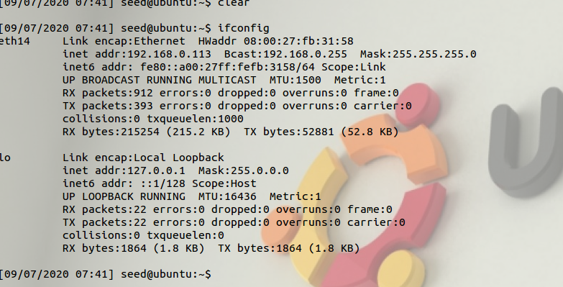

Machine 1 (Login through SSh command in 192.168.0.113)

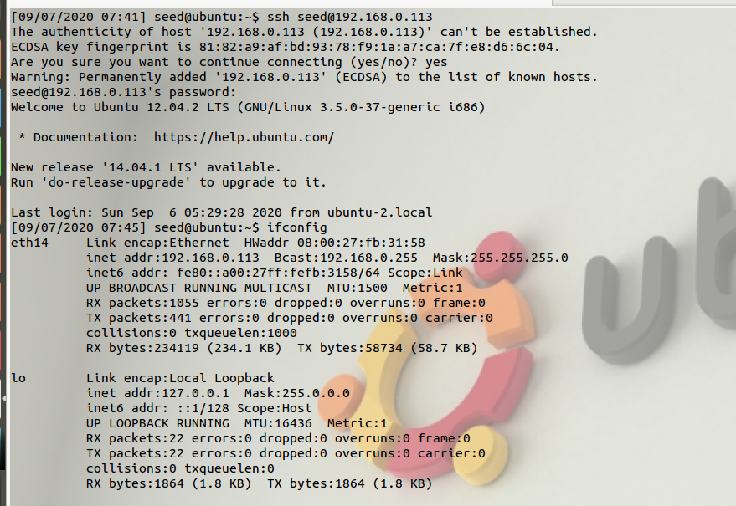

Then run command: sudo netwox 78 -i 192.168.0.113

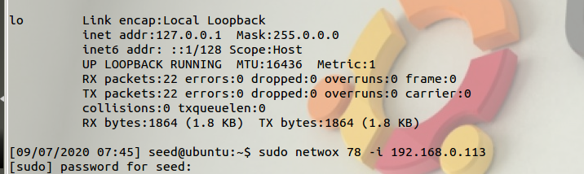

Captured on VM2:filter by (ip.src == 192.168.0.113&&ip.dst == 192.168.0.108) || (ip.dst == 192.168.0.113&&ip.src == 192.168.0.108)

